UNITED STATES
SECURITIES AND EXCHANGE COMMISSION
Washington, D.C. 20549

FORM 8-K

CURRENT REPORT
Pursuant to Section 13 or 15(d)
of the Securities Exchange Act of 1934
Date of Report (Date of earliest event reported): April 23, 2024

BGC Group, Inc.
(Exact name of Registrant as specified in its charter)

Delaware |  | 001-35591 |  | 86-3748217
(State or other jurisdiction  of incorporation) |  | (Commission  File Number) |  | (I.R.S. Employer  Identification No.)

499 Park Avenue
New York, NY |  | 10022
(Address of principal executive offices) |  | (Zip Code)
(212) 610-2200
Registrant’s telephone number, including area code
(Former Name or former address, if changed since last report)

Check the appropriate box below if the Form 8-K filing is intended to simultaneously satisfy the filing obligation of the registrant under any of the following provisions:

☐ | Written communications pursuant to Rule 425 under the Securities Act (17 CFR 230.425)

☐ | Soliciting material pursuant to Rule 14a-12 under the Exchange Act (17 CFR 240.14a-12)

☐ | Pre-commencement communications pursuant to Rule 14d-2(b) under the Exchange Act (17 CFR 240.14d-2(b))

☐ | Pre-commencement communications pursuant to Rule 13e-4(c) under the Exchange Act (17 CFR 240.13e-4(c))
Securities registered pursuant to Section 12(b) of the Act:

Title of each class |  | Trading  symbol(s) |  | Name of each exchange  on which registered
Class A Common Stock, $0.01 per share |  | BGC |  | The NASDAQ Stock Market LLC
Indicate by check mark whether the registrant is an emerging growth company as defined in Rule 405 of the Securities Act of 1933 (§230.405 of this chapter) or Rule 12b-2 of the Securities Exchange Act of 1934 (§240.12b-2 of this chapter).
Emerging growth company ☐
If an emerging growth company, indicate by check mark if the registrant has elected not to use the extended transition period for complying with any new or revised financial accounting standards provided pursuant to Section 13(a) of the Exchange Act. ☐

Item 7.01 Regulation FD Disclosure.
On April 25, 2024, BGC Group, Inc., a Delaware corporation (“BGC” or the “Company”), issued a press release announcing the investment in FMX (the “Investment”). A copy of the press release related to this announcement is attached as Exhibit 99.1 to this Current Report on Form 8-K.
A copy of the investor presentation relating to the Investment is attached as Exhibit 99.2 to this Current Report on Form 8-K.
The information furnished in this Item 7.01, including Exhibit 99.1 and Exhibit 99.2, shall not be deemed “filed” for purposes of Section 18 of the Securities Exchange Act of 1934, as amended (the “Exchange Act”), or otherwise subject to the liabilities of that Section, and shall not be deemed to be incorporated by reference into any filing of the Company under the Exchange Act or the Securities Act of 1933, as amended, except to the extent that the registrant specifically incorporates any such information by reference.
Item 9.01. Financial Statements and Exhibits.

Exhibit Number |  | Description
99.1 |  | BGC Group, Inc. press release, dated April 25, 2024
99.2 |  | Investor presentation, dated April 25, 2024
104 |  | Cover page interactive data file, submitted using inline XBRL

SIGNATURES
Pursuant to the requirements of the Securities Exchange Act of 1934, the registrant has duly caused this report to be signed on its behalf by the undersigned hereunto duly authorized.

Dated: April 25, 2024 |  |  |  | BGC GROUP, INC.
 |  |  |  | By: |  | /s/ Howard W. Lutnick
 |  |  |  | Name: |  | Howard W. Lutnick
 |  |  |  | Title: |  | Chairman of the Board and Chief Executive Officer

[Signature Page to Form 8-K, dated April 25, 2024, regarding FMX Investment]

Exhibit 99.1


Ten global investment banks and market making firms join BGC in the creation of FMX to launch premier U.S. Treasury and U.S. Interest Rate Futures trading marketplace
FMX closes transaction with strategic investors at a $667 million post-money equity valuation
NEW YORK – April 25, 2024 – BGC Group, Inc. (Nasdaq: BGC) today announced that Bank of America, Barclays, Citadel Securities, Citi, Goldman Sachs, J.P. Morgan, Jump Trading Group, Morgan Stanley, Tower Research Capital, and Wells Fargo have become minority equity owners of FMX, with a post-money equity valuation of $667 million. FMX combines BGC’s U.S. cash treasuries platform with its spot foreign exchange platform and U.S. interest rate futures exchange, and will leverage BGC’s proven low latency trading infrastructure and global distribution to further support liquidity in the interest rate futures market.
“We have brought together ten of the most important global investment banks and market making firms to create a premier trading venue for the interest rate markets,” said Howard W. Lutnick, Chairman and CEO of BGC Group and Chairman of FMX. “We offered ownership to this incredible investment group knowing the enormous value they bring to FMX, which will benefit all market participants.”
FMX Futures, which received CFTC approval in January, is expected to launch in September 2024. FMX’s cash U.S. Treasury platform, FMX UST (formerly known as Fenics UST), has grown its Central Limit Order Book market share each sequential quarter. FMX UST ended the first quarter 2024 at 28%, up from 26% in the fourth quarter of 2023.1
“With support from these leading financial firms, we believe FMX will become a rapidly growing futures platform and create important efficiencies for our shared clients,” said Lou Scotto, CEO of FMX. “With our clearing partner, LCH, the largest clearer of interest rate swaps in the world, clients will receive significant portfolio-margining capabilities, creating competitive advantages across U.S. interest rate markets.” 2
“LCH is excited to partner with FMX to deliver product innovation and margin savings, which will enhance the competitiveness of U.S. derivatives markets for its members,” said Isabelle Girolami, CEO of LCH Ltd.
“FMX’s unique protocols provide a fresh competitive edge across rates, FX, and futures markets,” said Geoff Weber, Head of G10 Rates Flow Trading at Citi. “The impressive growth in market share that FMX has experienced recently enhances market liquidity and positions FMX as a potential catalyst for increased competition, particularly within the futures market. This innovation not only promises to elevate market dynamics but also aims to lower costs for all market participants, signaling a forward-looking shift.”

1 | Central Limit Order Book (CLOB) is a mechanism financial exchanges use to facilitate trading between buyers and sellers in financial markets. Source: Coalition Greenwich.
2 | Source: Clarus.

“FMX is going to drive innovation and competition across the rates, FX and futures markets,” said Kristen Macleod, Head of Americas Macro Distribution and Co-Head of Global FX Distribution at Barclays. “As a key investor, Barclays looks forward to delivering the benefits of our investment to our clients through improved execution and competitive fees.”
Please find additional details about the FMX transaction at www.ir.bgcg.com. BGC will also provide additional information about the FMX transaction on its first quarter 2024 earnings call, scheduled for 10:00 a.m. ET on Tuesday, April 30, 2024.
About BGC Group, Inc.
BGC Group, Inc. (Nasdaq: BGC) is a leading global marketplace, data, and financial technology services company for a broad range of products, including fixed income, foreign exchange, energy, commodities, shipping, equities, and now includes the FMX Futures Exchange. BGC’s clients are many of the world’s largest banks, broker-dealers, investment banks, trading firms, hedge funds, governments, corporations, and investment firms.
BGC and leading global investment banks and market making firms have partnered to create FMX, part of the BGC Group of companies, which includes a U.S. interest rate futures exchange, spot foreign exchange platform and the world’s fastest growing U.S. cash treasuries platform.
For more information about BGC, please visit www.bgcg.com.
Discussion of Forward-Looking Statements about BGC
Statements in this document regarding BGC that are not historical facts are “forward-looking statements” that involve risks and uncertainties, which could cause actual results to differ from those contained in the forward-looking statements. These include statements about the Company’s business, results, financial position, liquidity and outlook, which may constitute forward-looking statements and are subject to the risk that the actual impact may differ, possibly materially, from what is currently expected. Except as required by law, BGC undertakes no obligation to update any forward-looking statements. For a discussion of additional risks and uncertainties, which could cause actual results to differ from those contained in the forward-looking statements, see BGC’s Securities and Exchange Commission (“SEC”) filings, including, but not limited to, the risk factors and Special Note on Forward-Looking Information set forth in these filings and any updates to such risk factors and Special Note on Forward-Looking Information contained in subsequent reports on Form 10-K, Form 10-Q or Form 8-K.
MEDIA CONTACTS:
BGC Group
Erica Chase
erica.chase@cantor.com
+1 212-610-2419
Barclays
Sofia Rehman
sofia.rehman@barclays.com
Citi
Rekha Jogia-Soni
Rekha.JogiaSoni@citi.com
INVESTOR CONTACT:
Jason Chryssicas
+1 212-610-2426

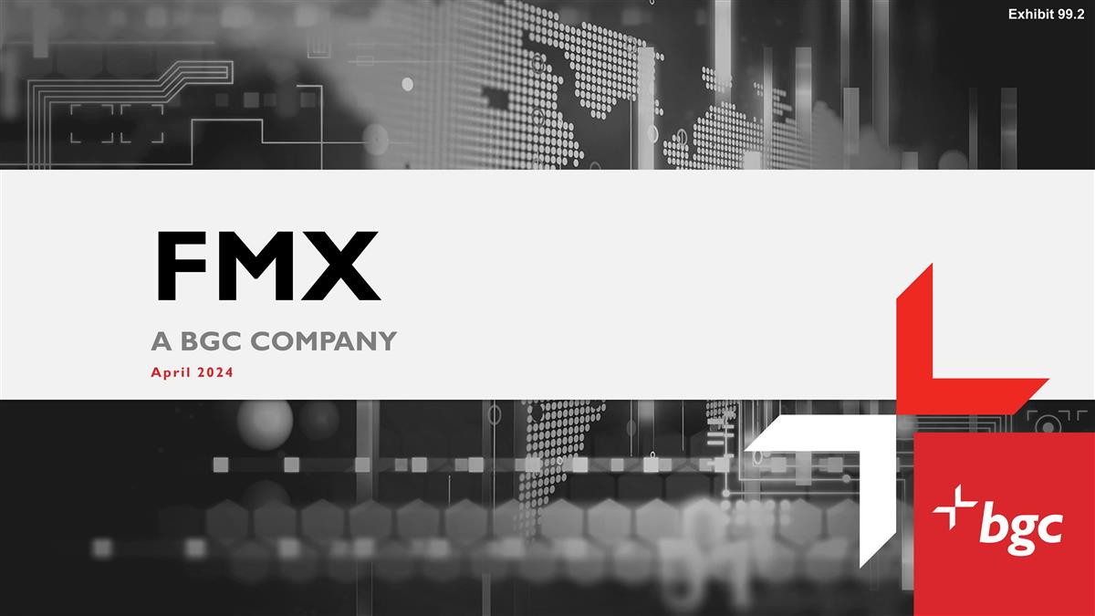
FMX A BGC COMPANY April 2024 Exhibit 99.2

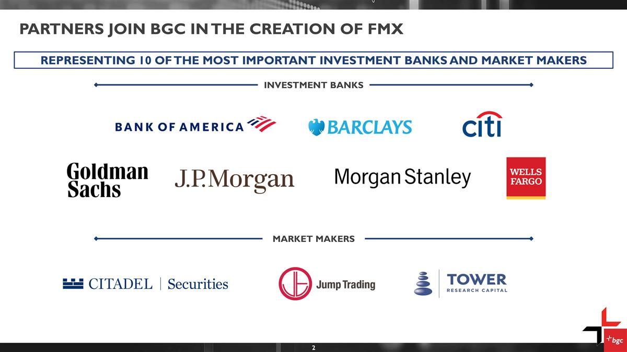
Partners Join BGC in the creation of FMX REPRESENTING 10 OF THE MOST IMPORTANT INVESTMENT BANKS AND MARKET MAKERS INVESTMENT BANKS MARKET MAKERS

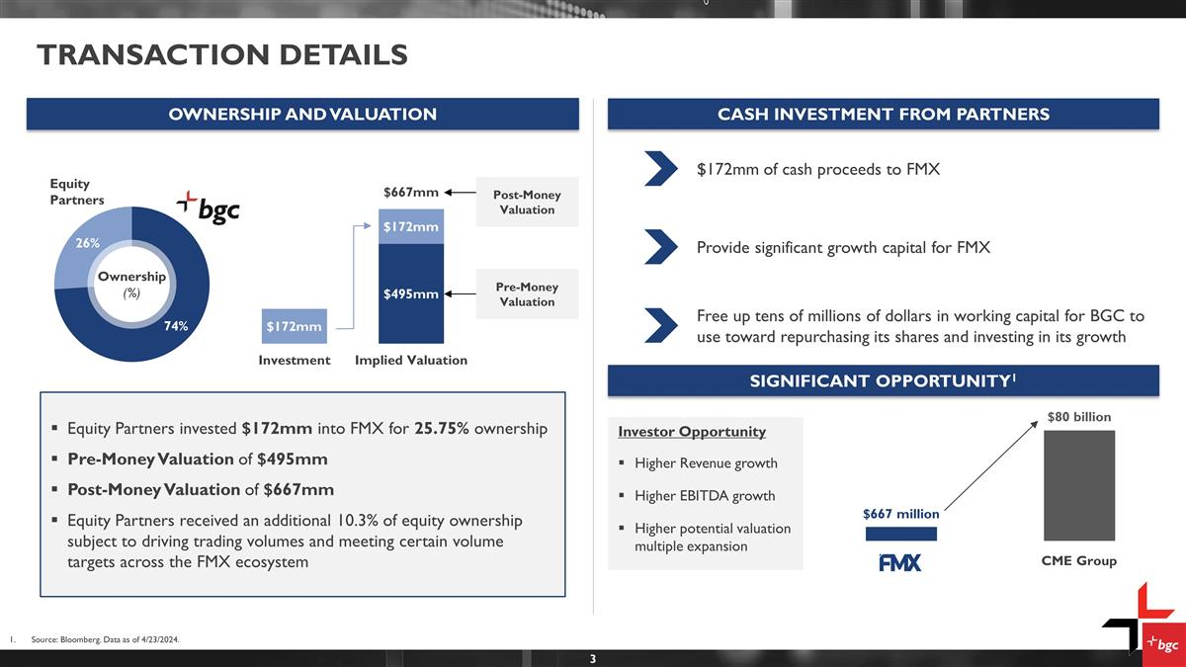
Provide significant growth capital for FMX $172mm of cash proceeds to FMX TRANSACTION DETAILS CASH INVESTMENT FROM PARTNERS OWNERSHIP AND VALUATION Ownership (%) Pre-Money Valuation Post-Money Valuation Equity Partners SIGNIFICANT OPPORTUNITY1 Source: Bloomberg. Data as of 4/23/2024. Investor Opportunity Higher Revenue growth Higher EBITDA growth Higher potential valuation multiple expansion CME Group Free up tens of millions of dollars in working capital for BGC to use toward repurchasing its shares and investing in its growth Equity Partners invested $172mm into FMX for 25.75% ownership Pre-Money Valuation of $495mm Post-Money Valuation of $667mm Equity Partners received an additional 10.3% of equity ownership subject to driving trading volumes and meeting certain volume targets across the FMX ecosystem

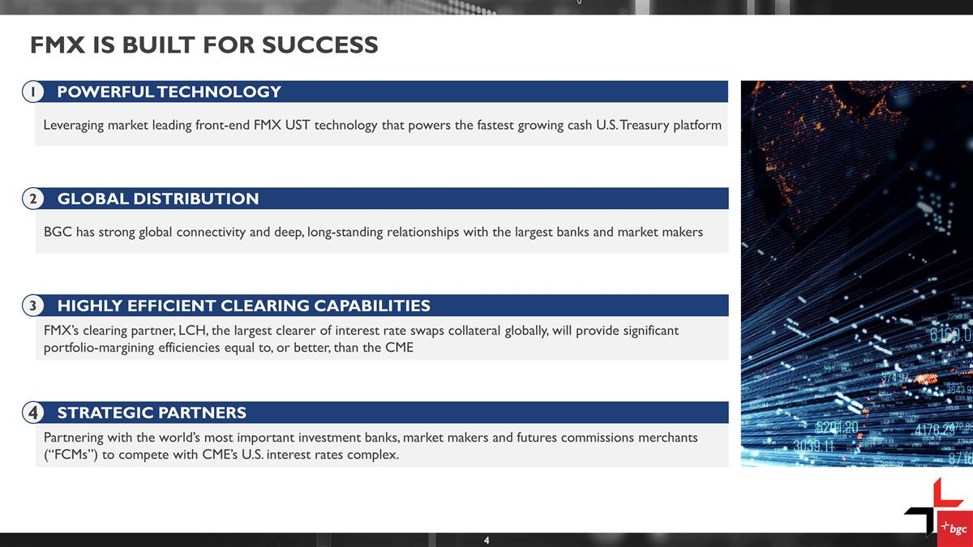
FMX is built for success Leveraging market leading front-end FMX UST technology that powers the fastest growing cash U.S. Treasury platform POWERFUL TECHNOLOGY 1 BGC has strong global connectivity and deep, long-standing relationships with the largest banks and market makers GLOBAL DISTRIBUTION 2 FMX’s clearing partner, LCH, the largest clearer of interest rate swaps collateral globally, will provide significant portfolio-margining efficiencies equal to, or better, than the CME HIGHLY EFFICIENT CLEARING CAPABILITIES 3 Partnering with the world’s most important investment banks, market makers and futures commissions merchants (“FCMs”) to compete with CME’s U.S. interest rates complex. STRATEGIC PARTNERS 4

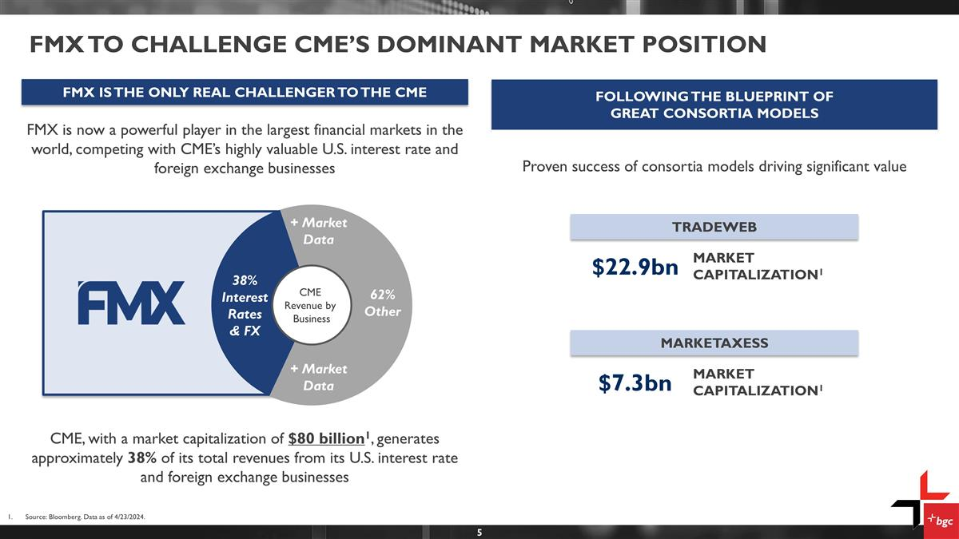
FMX To challenge CME’s DOMINANT MARKET POSITION FMX is now a powerful player in the largest financial markets in the world, competing with CME’s highly valuable U.S. interest rate and foreign exchange businesses CME Revenue by Business 38% Interest Rates & FX 62% Other FOLLOWING THE BLUEPRINT OF GREAT CONSORTIA MODELS FMX IS THE ONLY REAL CHALLENGER TO THE CME CME, with a market capitalization of $80 billion1, generates approximately 38% of its total revenues from its U.S. interest rate and foreign exchange businesses Proven success of consortia models driving significant value TRADEWEB MARKET CAPITALIZATION1 $22.9bn MARKETAXESS MARKET CAPITALIZATION1 $7.3bn Source: Bloomberg. Data as of 4/23/2024. + Market Data + Market Data

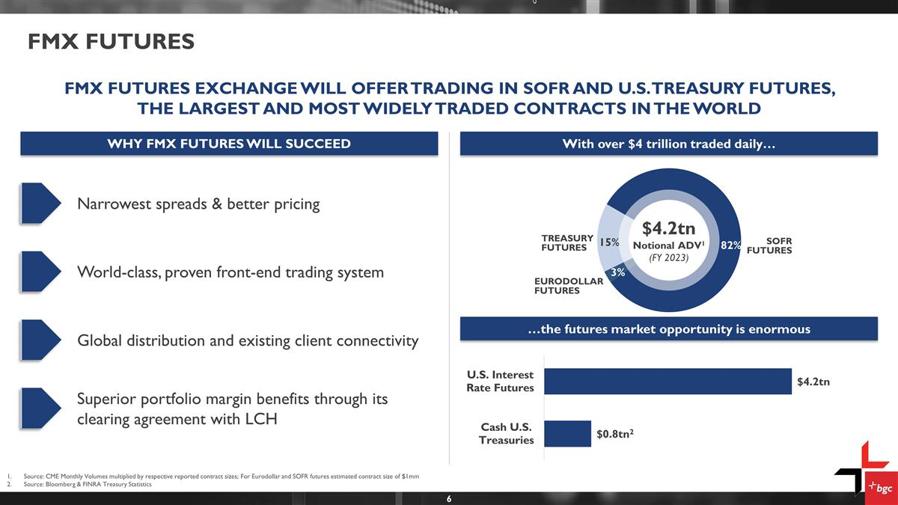
Source: CME Monthly Volumes multiplied by respective reported contract sizes; For Eurodollar and SOFR futures estimated contract size of $1mm Source: Bloomberg & FINRA Treasury Statistics …the futures market opportunity is enormous FMX FUTURES U.S. INTEREST RATE FUTURES1 Narrowest spreads & better pricing World-class, proven front-end trading system Global distribution and existing client connectivity Superior portfolio margin benefits through its clearing agreement with LCH FMX FUTURES EXCHANGE WILL OFFER TRADING IN SOFR AND U.S. TREASURY FUTURES, THE LARGEST AND MOST WIDELY TRADED CONTRACTS IN THE WORLD $4.2tn Notional ADV1 (FY 2023) SOFR FUTURES EURODOLLAR FUTURES TREASURY FUTURES WHY FMX FUTURES WILL SUCCEED With over $4 trillion traded daily…

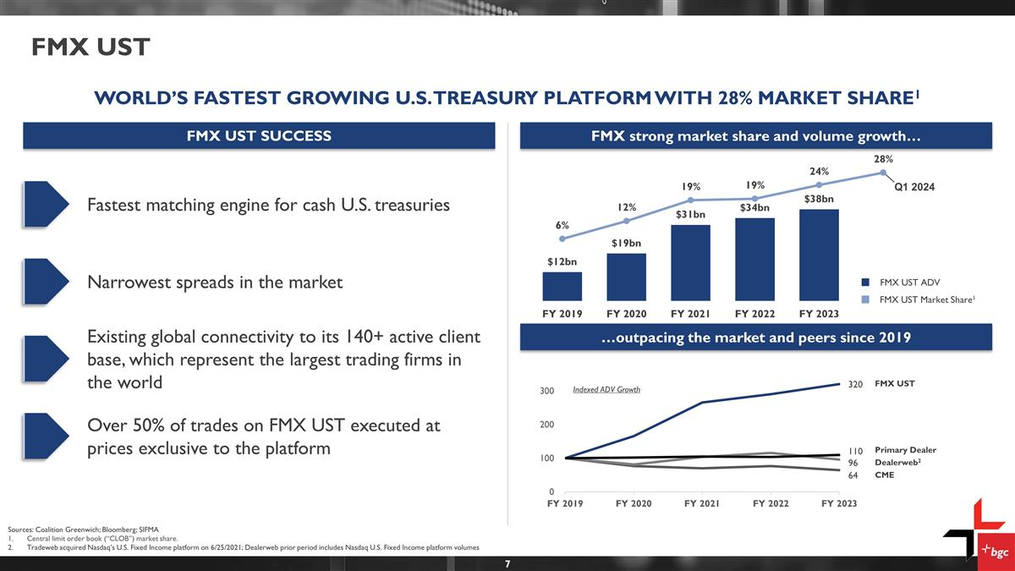
FMX strong market share and volume growth… FMX UST FMX UST ADV FMX UST Market Share1 Sources: Coalition Greenwich; Bloomberg; SIFMA Central limit order book (“CLOB”) market share. Tradeweb acquired Nasdaq’s U.S. Fixed Income platform on 6/25/2021; Dealerweb prior period includes Nasdaq U.S. Fixed Income platform volumes Q1 2024 WORLD’S FASTEST GROWING U.S. TREASURY PLATFORM WITH 28% MARKET SHARE1 FMX UST Primary Dealer CME Dealerweb2 Indexed ADV Growth …outpacing the market and peers since 2019 FMX UST SUCCESS Fastest matching engine for cash U.S. treasuries Narrowest spreads in the market Existing global connectivity to its 140+ active client base, which represent the largest trading firms in the world Over 50% of trades on FMX UST executed at prices exclusive to the platform

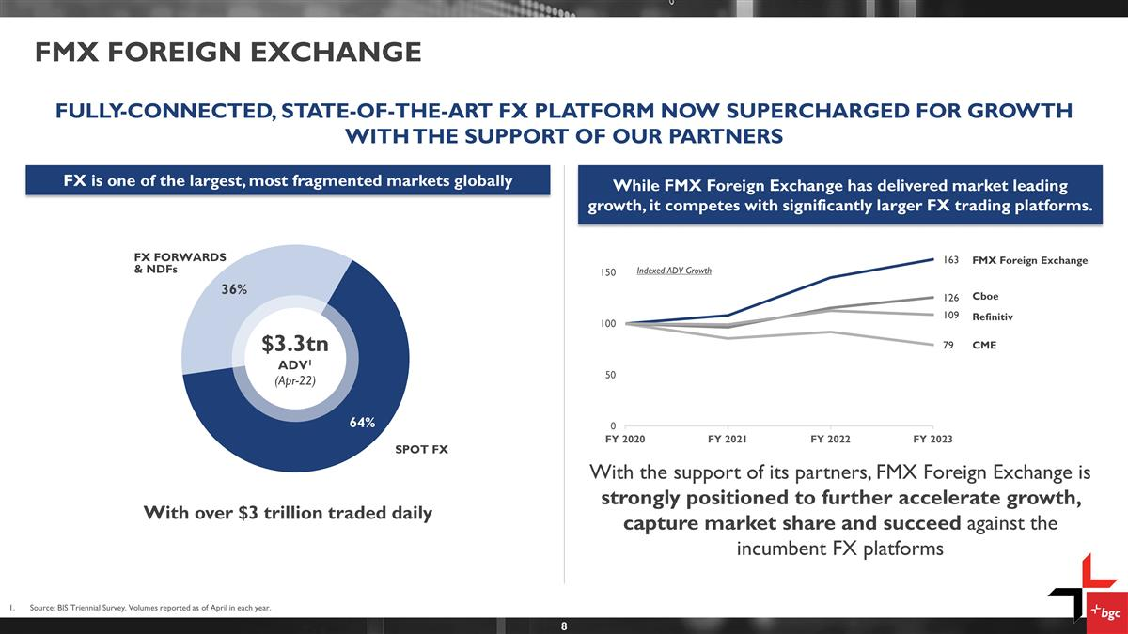
FMX Foreign exchange FULLY-CONNECTED, STATE-OF-THE-ART FX PLATFORM NOW SUPERCHARGED FOR GROWTH WITH THE SUPPORT OF OUR PARTNERS While FMX Foreign Exchange has delivered market leading growth, it competes with significantly larger FX trading platforms. Source: BIS Triennial Survey. Volumes reported as of April in each year. FX is one of the largest, most fragmented markets globally $3.3tn ADV1 (Apr-22) SPOT FX FX FORWARDS & NDFs With over $3 trillion traded daily FMX Foreign Exchange CME Cboe Refinitiv Indexed ADV Growth With the support of its partners, FMX Foreign Exchange is strongly positioned to further accelerate growth, capture market share and succeed against the incumbent FX platforms

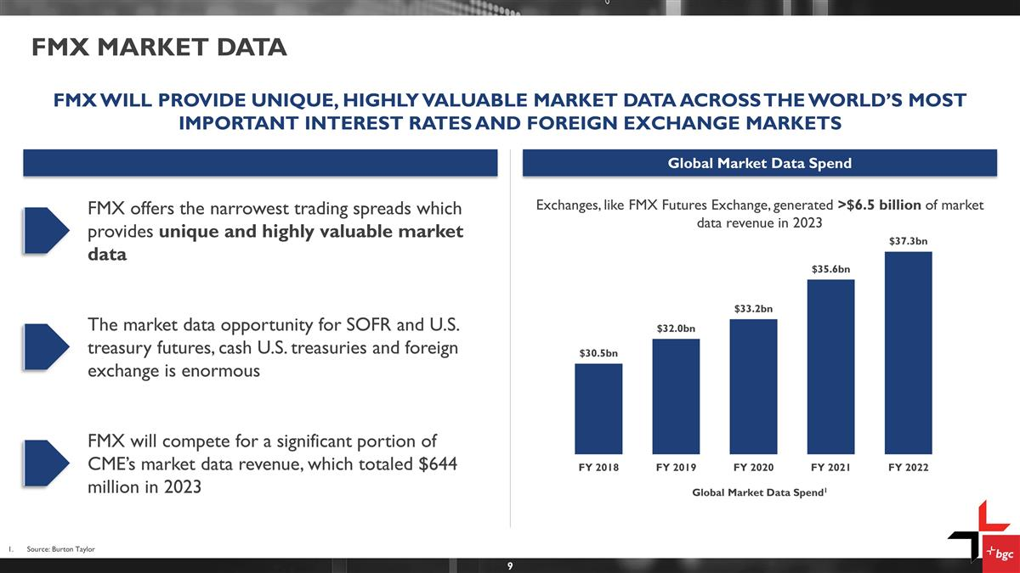
FMX MARKET DATA Source: Burton Taylor FMX WILL PROVIDE UNIQUE, HIGHLY VALUABLE MARKET DATA ACROSS THE WORLD’S MOST IMPORTANT INTEREST RATES AND FOREIGN EXCHANGE MARKETS Global Market Data Spend Global Market Data Spend1 FMX offers the narrowest trading spreads which provides unique and highly valuable market data The market data opportunity for SOFR and U.S. treasury futures, cash U.S. treasuries and foreign exchange is enormous FMX will compete for a significant portion of CME’s market data revenue, which totaled $644 million in 2023 Exchanges, like FMX Futures Exchange, generated >$6.5 billion of market data revenue in 2023

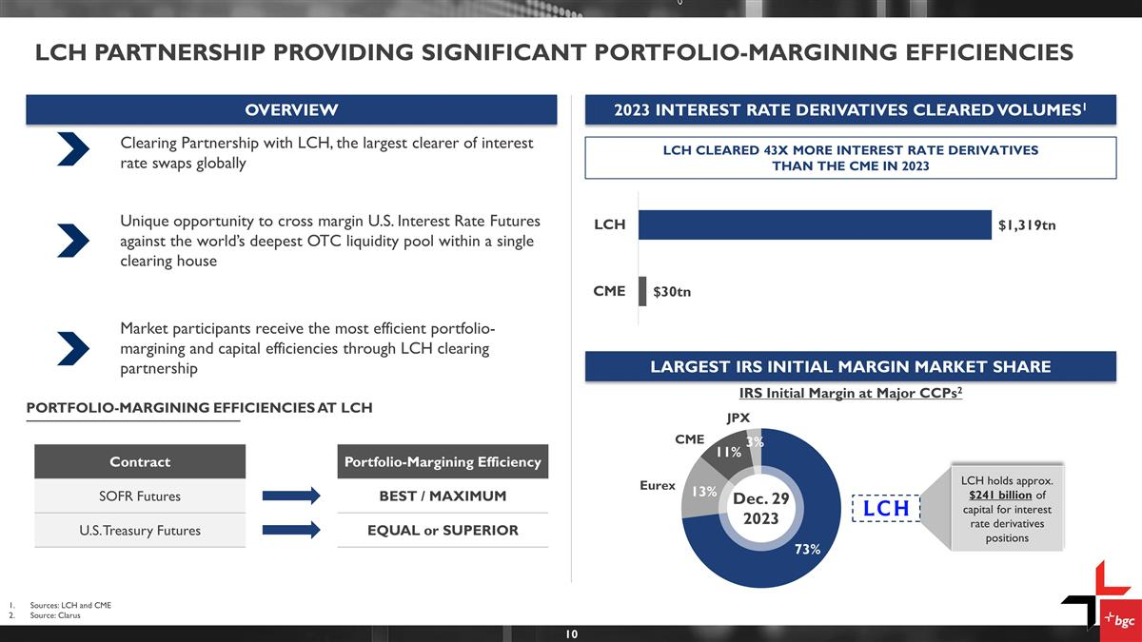
LCH Partnership PROVIDING significant PORTFOLIO-margining Efficiencies 2023 INTEREST RATE DERIVATIVES CLEARED VOLUMES1 OVERVIEW LARGEST IRS INITIAL MARGIN MARKET SHARE Clearing Partnership with LCH, the largest clearer of interest rate swaps globally Unique opportunity to cross margin U.S. Interest Rate Futures against the world’s deepest OTC liquidity pool within a single clearing house Market participants receive the most efficient portfolio-margining and capital efficiencies through LCH clearing partnership PORTFOLIO-MARGINING EFFICIENCIES AT LCH LCH CLEARED 43X MORE INTEREST RATE DERIVATIVES THAN THE CME IN 2023 Dec. 29 2023 Eurex JPX CME IRS Initial Margin at Major CCPs2 LCH holds approx. $241 billion of capital for interest rate derivatives positions Sources: LCH and CME Source: Clarus Contract Portfolio-Margining Efficiency SOFR Futures BEST / MAXIMUM U.S. Treasury Futures EQUAL or SUPERIOR

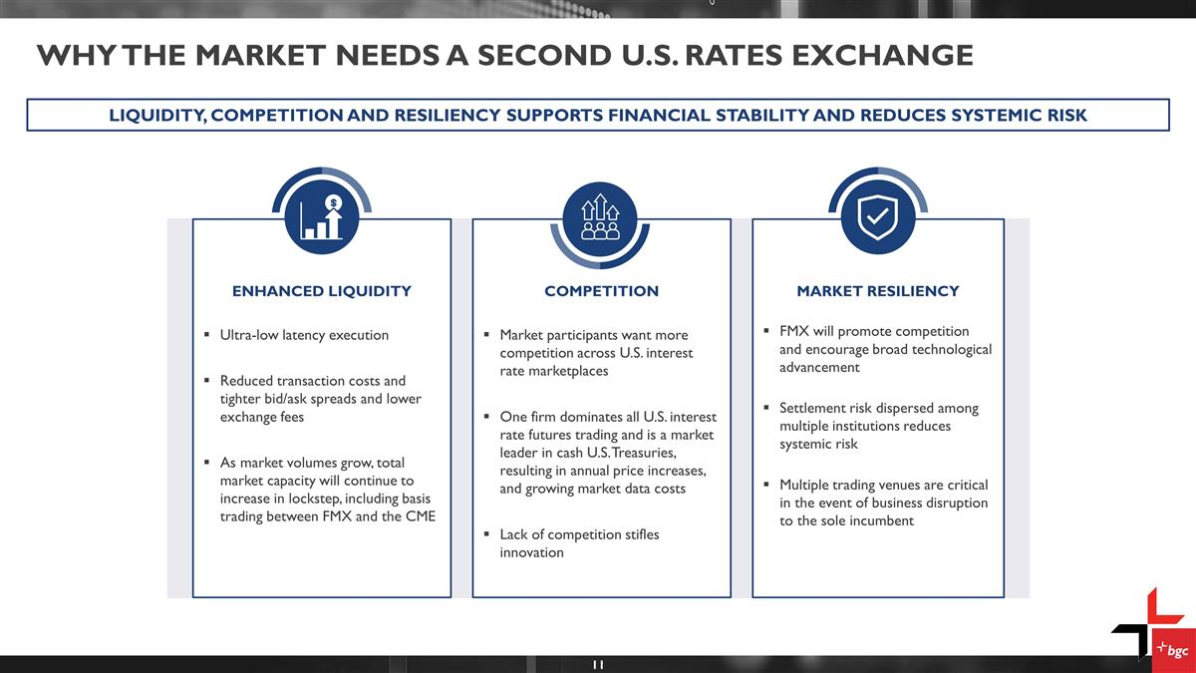
Why THE MARKET NEEDs A SECOND U.S. RATES EXCHANGE LIQUIDITY, COMPETITION AND RESILIENCY SUPPORTS FINANCIAL STABILITY AND REDUCES SYSTEMIC RISK ENHANCED LIQUIDITY Ultra-low latency execution Reduced transaction costs and tighter bid/ask spreads and lower exchange fees As market volumes grow, total market capacity will continue to increase in lockstep, including basis trading between FMX and the CME COMPETITION Market participants want more competition across U.S. interest rate marketplaces One firm dominates all U.S. interest rate futures trading and is a market leader in cash U.S. Treasuries, resulting in annual price increases, and growing market data costs Lack of competition stifles innovation MARKET RESILIENCY FMX will promote competition and encourage broad technological advancement Settlement risk dispersed among multiple institutions reduces systemic risk Multiple trading venues are critical in the event of business disruption to the sole incumbent

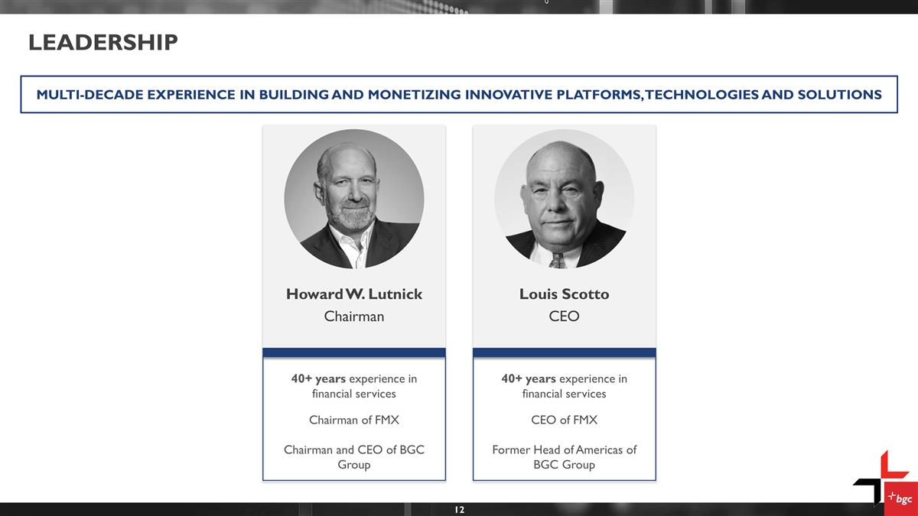
Leadership MULTI-DECADE EXPERIENCE IN BUILDING AND MONETIZING INNOVATIVE PLATFORMS, TECHNOLOGIES AND SOLUTIONS Louis Scotto CEO Howard W. Lutnick Chairman 40+ years experience in financial services Chairman of FMX Chairman and CEO of BGC Group 40+ years experience in financial services CEO of FMX Former Head of Americas of BGC Group

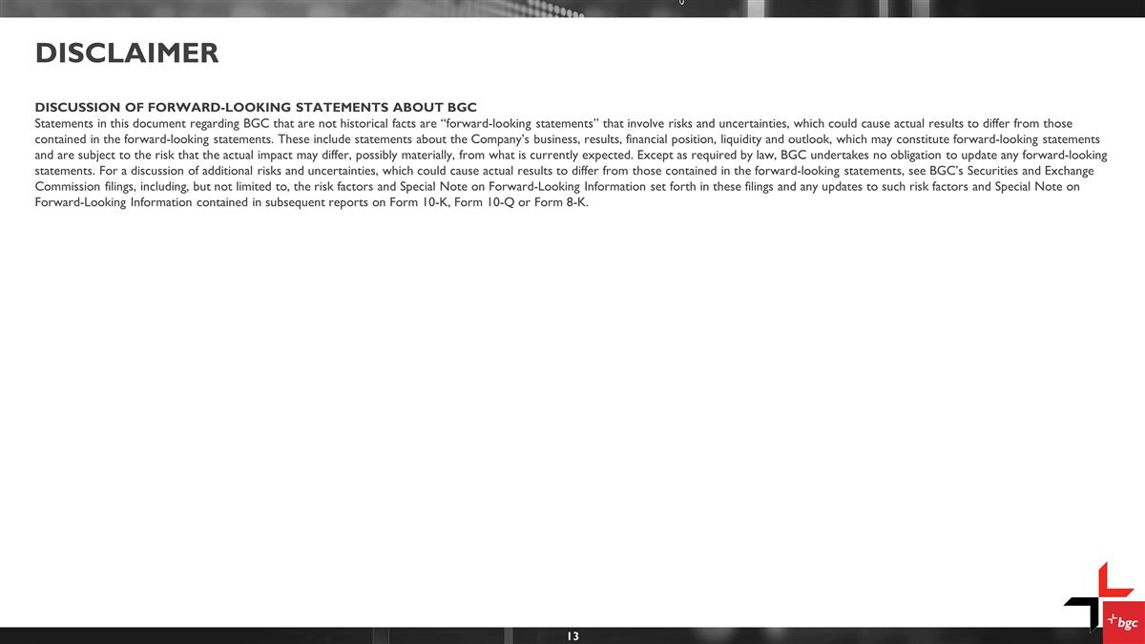
Disclaimer DISCUSSION OF FORWARD-LOOKING STATEMENTS ABOUT BGC Statements in this document regarding BGC that are not historical facts are “forward-looking statements” that involve risks and uncertainties, which could cause actual results to differ from those contained in the forward-looking statements. These include statements about the Company’s business, results, financial position, liquidity and outlook, which may constitute forward-looking statements and are subject to the risk that the actual impact may differ, possibly materially, from what is currently expected. Except as required by law, BGC undertakes no obligation to update any forward-looking statements. For a discussion of additional risks and uncertainties, which could cause actual results to differ from those contained in the forward-looking statements, see BGC’s Securities and Exchange Commission filings, including, but not limited to, the risk factors and Special Note on Forward-Looking Information set forth in these filings and any updates to such risk factors and Special Note on Forward-Looking Information contained in subsequent reports on Form 10-K, Form 10-Q or Form 8-K.

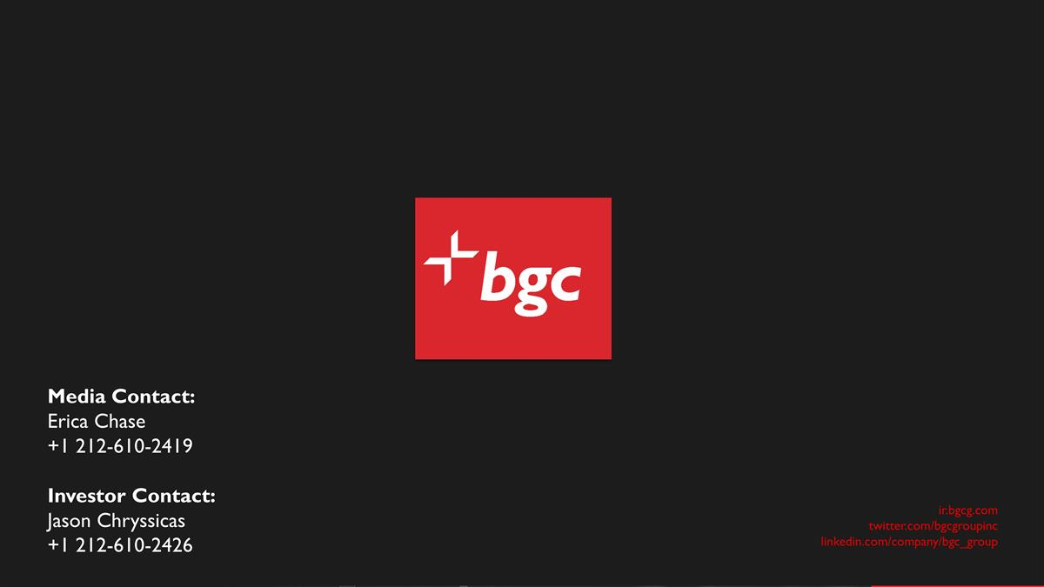
ir.bgcg.com twitter.com/bgcgroupinc linkedin.com/company/bgc_group Media Contact: Erica Chase +1 212-610-2419 Investor Contact: Jason Chryssicas +1 212-610-2426

